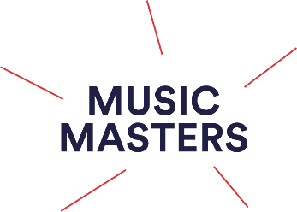


Date:

School/ Organisation Information for Observations for Musicians of Change: PGCEi in Group Instrument Teaching, (recorded and in – person)

Dear….,

Musicians of Change (PGCEi in Group Instrument Learning) is a Masters Level Teaching qualification delivered in partnership between music education charity, Music Masters and Birmingham City University. Teachers currently taking part on the course will have their teaching observed by their mentor three times across the academic, once per term. This is to help them analyse their current teaching, identify areas of development to work on with their mentor, track their progress and understand the impact of their teaching on both their learners and schools within they work. The observations, feedback and reflections are used as part of their written coursework submitted as part of a portfolio at toward the end of the course.

Some Musicians of PGCEi students may record or have their teaching observed either online via a Zoom call or being videoed so that they are able to complete their qualification. For this reason your teacher may ask for your lesson to be recorded so that they can share the lesson with their mentor. For this we have supplied teachers undertaking the course with letters seeking permission from the children’s parents or carers for the lesson to be recorded and shared with their mentor and/ or in a piece or written coursework.

If using video, how will the video be used?
The video itself will be uploaded as an unlisted video on youtube on your teacher’s private account, which means it cannot be searched for or available to the public. Only the parent or carer, teacher and mentor or marker will be able to view it if the link is shared with them. The video will then be deleted from your teacher’s youtube account once the observation feedback and marking has been completed and the link will no longer be available. Using youtube in this way means that the video cannot be downloaded.

If you have any further questions about this process, do not hesitate to get in contact with us at pgcei@musicmasters.org.uk - we are more than happy to help.

Thank you and we appreciate you support for the training of our PGCEi students.

Katrina Damigos

Head of Teacher Training Programmes and Musicians of Change (PGCEi) Course Leader

The Musicians of Change (PGCEi) Team

Musicmasters.org.uk
Register Charity No. 1119372

