
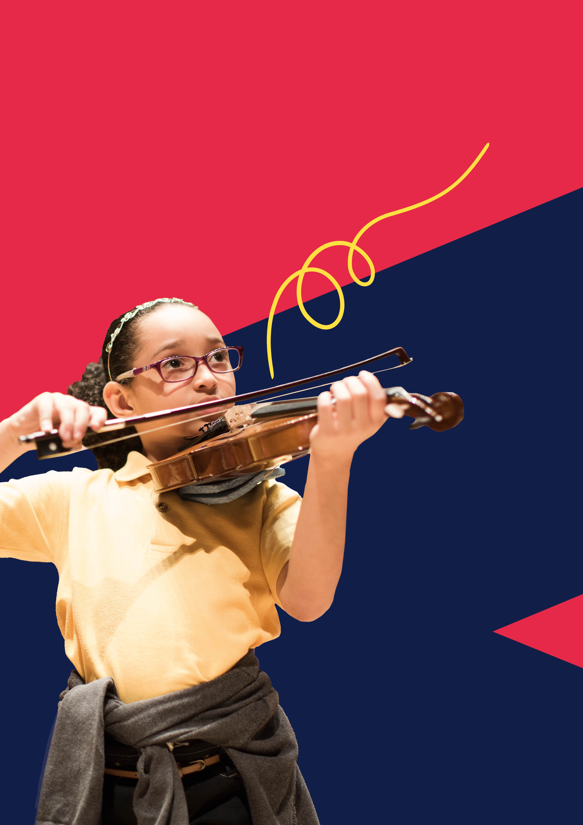

1. Lesson Plan
Lesson Information
Date & Time (start & finish):
Class Type (instrument, age, number of pupils, lesson number out of total in term, etc.):

Teaching Standards Addressed
Aims for Lesson Information
To provide opportunities for learners to:

Intended Outcomes
Repertoire & Resources Used
Diversity & Inclusion
Consider the following areas when planning your lesson:
Classroom setup-How are you going to set up the room to engage and support learners?

Incorporation of Youth & Child Voice- How are you going to try and incorporate the learners voice in the lesson?

Celebrating diversity in lesson content- How will you embed and celebrate diversity into the lesson content?
Adaptability and differentiation- How will you adapt and differentiate content and your approach to accommodate different learners needs?
The Lesson
Stage in Lesson  Beginning, middle, end | Intent  What is the intended learning? Why are we doing this? | Implementation  What teacher/student activities will this lesson include? How will they be organised & delivered? | Impact  What exactly will I assess? How? What am I looking for? How will I know this has been achieved?

Evaluation
How effective do you believe your strategies were in the lesson?
What methods/approaches did you use when working with school teachers, classroom assistants and/or other key stakeholders in your lesson?
How well do you believe you embedded diversity and inclusion into your teaching practices and lesson?
Are there key moments that stood out for you? If so, why did these stand out?
What might you do differently next time?


UK Music Masters Ltd is a registered charity, number 1119372,
and its company number is 06226749
2. Lesson Plan
Lesson Information
Date & Time (start & finish):
Class Type (instrument, age, number of pupils, lesson number out of total in term, etc.):

Teaching Standards Addressed
Aims for Lesson Information
To provide opportunities for learners to:

Intended Outcomes
Repertoire & Resources Used
Diversity & Inclusion
Consider the following areas when planning your lesson:
Classroom setup-How are you going to set up the room to engage and support learners?

Incorporation of Youth & Child Voice- How are you going to try and incorporate the learners voice in the lesson?

Celebrating diversity in lesson content- How will you embed and celebrate diversity into the lesson content?
Adaptability and differentiation- How will you adapt and differentiate content and your approach to accommodate different learners needs?
The Lesson
Stage in Lesson  Beginning, middle, end | Intent  What is the intended learning? Why are we doing this? | Implementation  What teacher/student activities will this lesson include? How will they be organised & delivered? | Impact  What exactly will I assess? How? What am I looking for? How will I know this has been achieved?

Evaluation
How effective do you believe your strategies were in the lesson?
What methods/approaches did you use when working with school teachers, classroom assistants and/or other key stakeholders in your lesson?
How well do you believe you embedded diversity and inclusion into your teaching practices and lesson?
Are there key moments that stood out for you? If so, why did these stand out?
What might you do differently next time?

3. Lesson Plan
Lesson Information
Date & Time (start & finish):
Class Type (instrument, age, number of pupils, lesson number out of total in term, etc.):

Teaching Standards Addressed
Aims for Lesson Information
To provide opportunities for learners to:

Intended Outcomes
Repertoire & Resources Used
Diversity & Inclusion
Consider the following areas when planning your lesson:
Classroom setup-How are you going to set up the room to engage and support learners?

Incorporation of Youth & Child Voice- How are you going to try and incorporate the learners voice in the lesson?

Celebrating diversity in lesson content- How will you embed and celebrate diversity into the lesson content?
Adaptability and differentiation- How will you adapt and differentiate content and your approach to accommodate different learners needs?
The Lesson
Stage in Lesson  Beginning, middle, end | Intent  What is the intended learning? Why are we doing this? | Implementation  What teacher/student activities will this lesson include? How will they be organised & delivered? | Impact  What exactly will I assess? How? What am I looking for? How will I know this has been achieved?

Evaluation
How effective do you believe your strategies were in the lesson?
What methods/approaches did you use when working with school teachers, classroom assistants and/or other key stakeholders in your lesson?
How well do you believe you embedded diversity and inclusion into your teaching practices and lesson?
Are there key moments that stood out for you? If so, why did these stand out?
What might you do differently next time?

