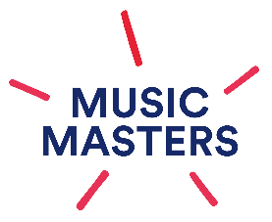
Music Masters Flagship Schools Programme
Musicianship: Lesson Plan

School

Year Group

Term

Week

Learning objectives (from the Music Masters Curriculum Framework)

Activities |  | Links to resources

Starter

Main

Plenary

